Do Your “Doody” for Clean Water

You hate stepping in it. And fish hate swimming in it, too! Dogs produce a lot of waste which, if not disposed of properly, can end up in our waterways. Do your part to keep our waters and public areas clean and healthy! Bag your pet’s waste and throw it in a trash can.
DO | DON’T
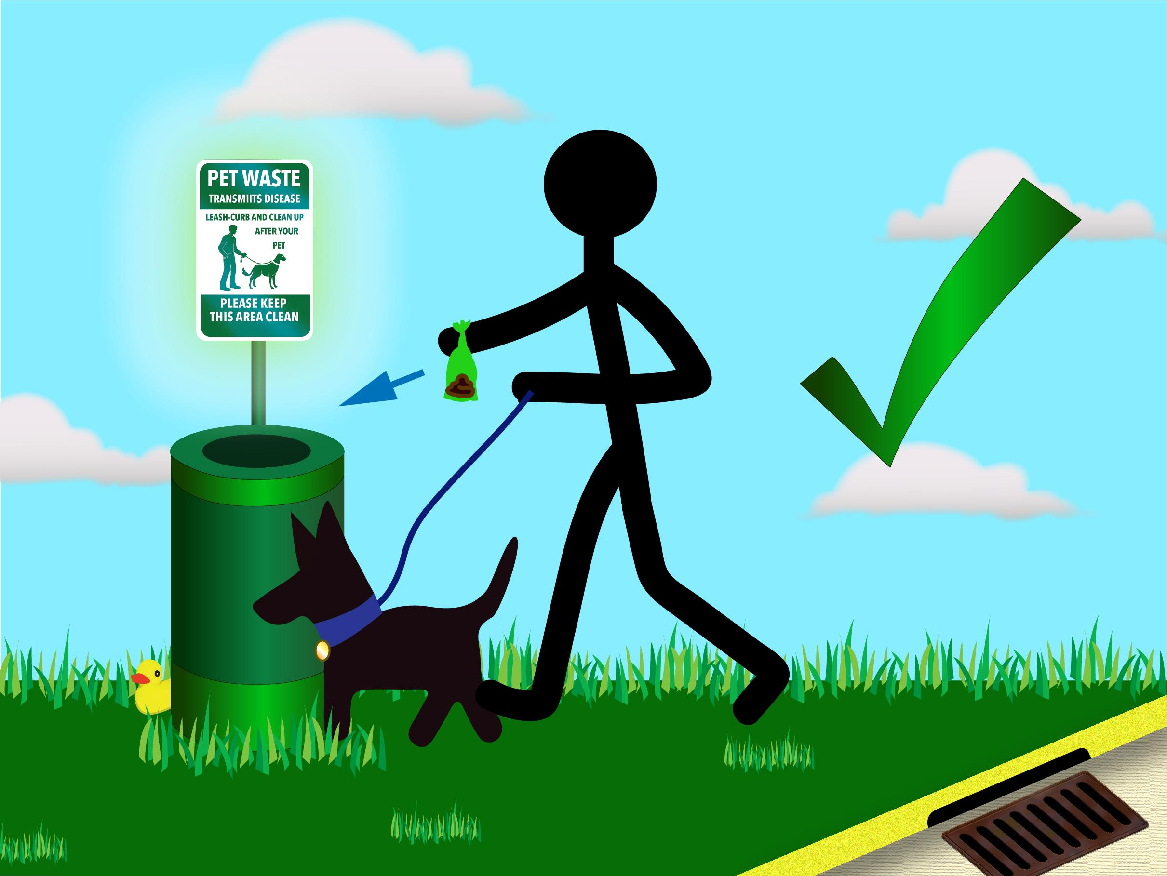 | 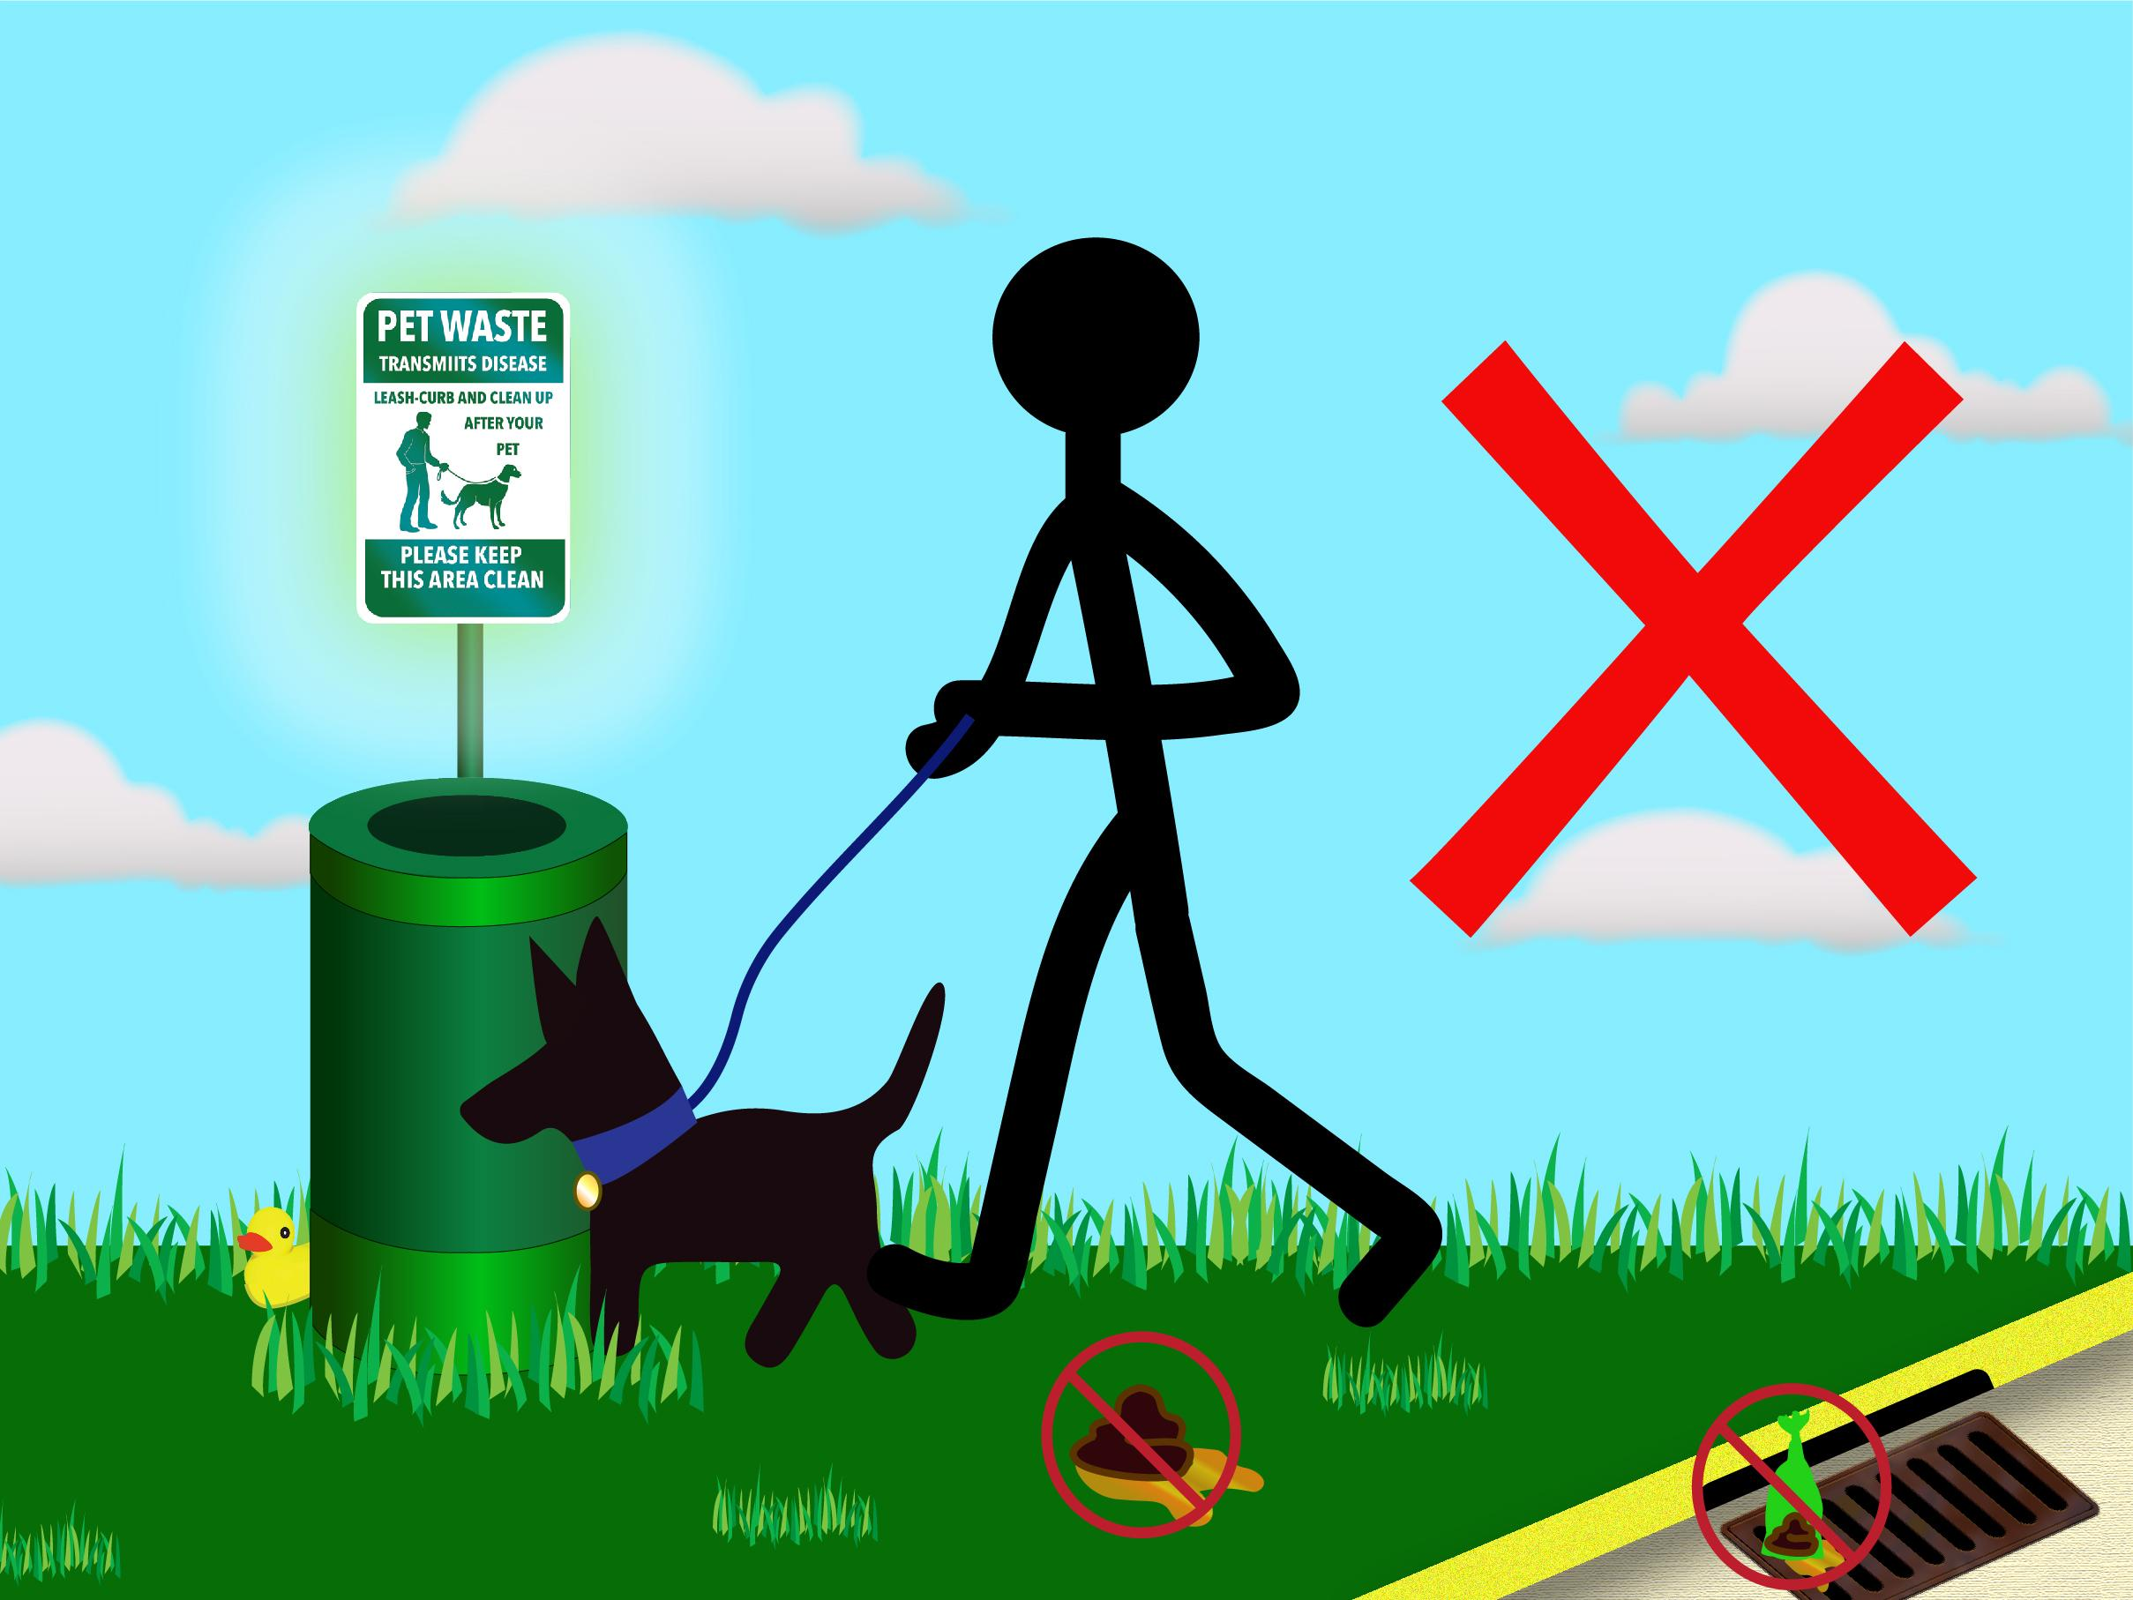

Did you know that the average dog can produce nearly a pound of waste each day?
- Pet waste left on lawns and in public spaces is not only gross. It can be quite harmful too.
- Pet waste contains twice as much bacteria as human waste!
- If left in your yard, pet waste can kill grass and other plants.
- Adults and children who come in contact with it can get sick.
- When pet waste washes into storm drains and waterways, it can make the water unhealthy for people and wildlife.
- Pet waste in waterways can even cause algae to grow, making the water turn an unpleasant green color.

Do your "doody" in both public areas and in your yard.

To learn more, visit the www.ThinkBlueMassachusetts.org

